**WEB TECHNOLOGIES**

**MID 1 ANSWERS**

**MODULE 1**

1. **Demonstrate call by value and call by reference functions in PHP with examples**

**Ans:**

**Call by value:**

Call by value method copies the value of an argument into the formal parameter of that function. Therefore, changes made to the parameter of the main function do not affect the argument.

In this parameter passing method, values of actual parameters are copied to function’s formal parameters, and the parameters are stored in different memory locations. So any changes made inside functions are not reflected in actual parameters of the caller.

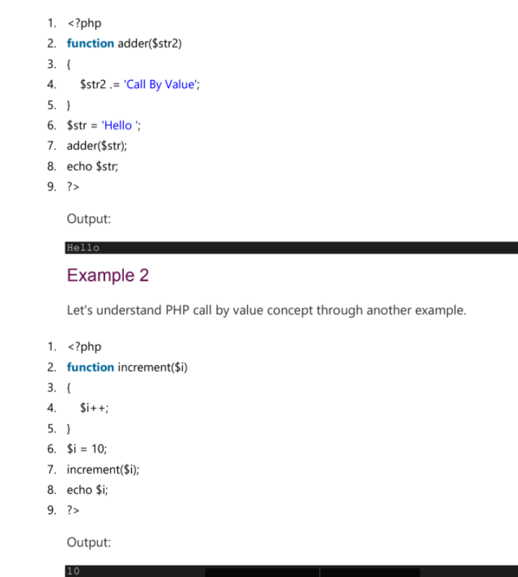

**Call by reference:**

Call by reference method copies the address of an argument into the formal parameter. In this method, the address is used to access the actual argument used in the function call. It means that changes made in the parameter alter the passing argument.

In this method, the memory allocation is the same as the actual parameters. All the operation in the function are performed on the value stored at the address of the actual parameter, and the modified value will be stored at the same address.

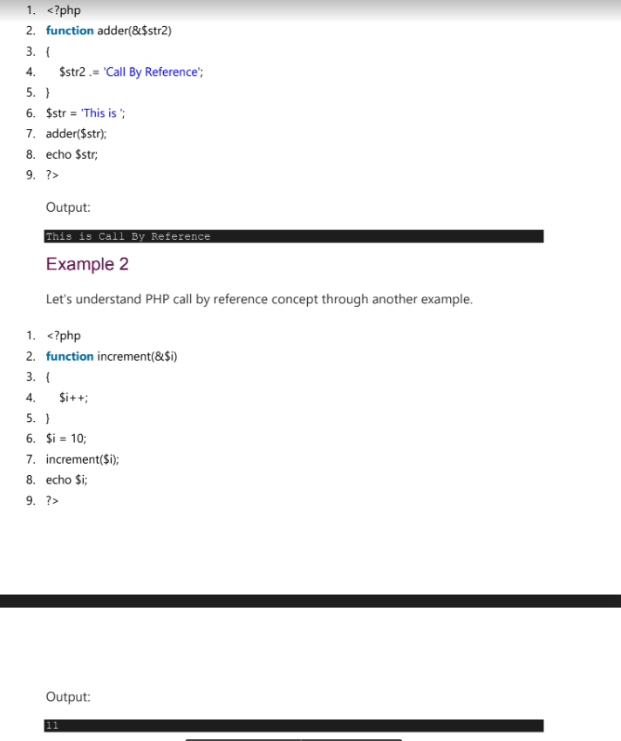

1. **Write a program to explain about the concept of arrays in PHP.**

**Ans:**

**PHP Arrays**

PHP array is an ordered map (contains value on the basis of key). It is used to hold multiple values of similar type in a single variable.

**PHP Array Types**

There are 3 types of array in PHP.

1. Indexed Array

2. Associative Array

3. Multidimensional Array

**Indexed Array**

PHP index is represented by number which starts from 0. We can store number,string and object in the PHP array. All PHP array elements are assigned to an indexnumber by default.

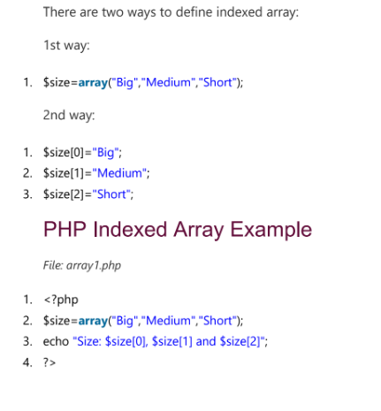

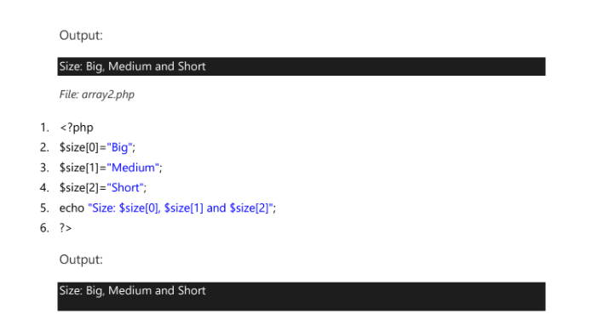

**Associative Array**

These types of arrays are similar to the indexed arrays but instead of linear storage, every value can be assigned with a user-defined key of string type. We can associate name with each array elements in PHP using => symbol.

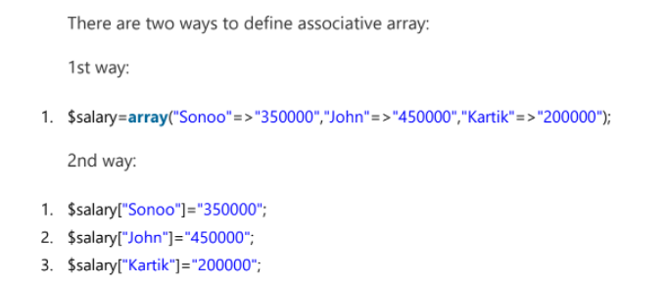

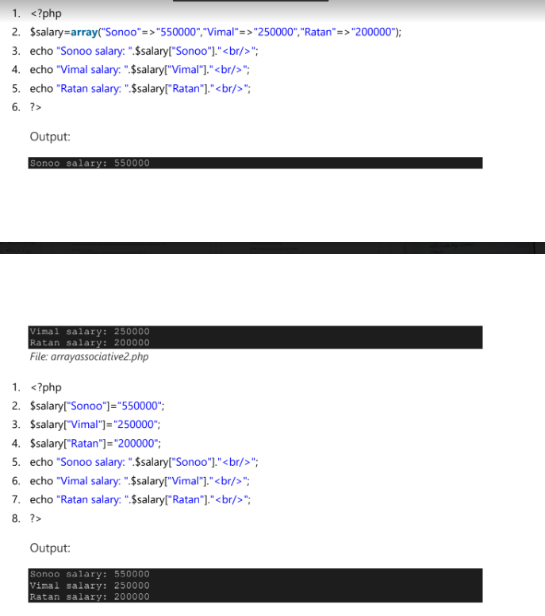

**Multidimensional Array**

PHP multidimensional array is also known as array of arrays. It allows you to store tabular data in an array. PHP multidimensional array can be represented in the form of matrix which is represented by row * column.

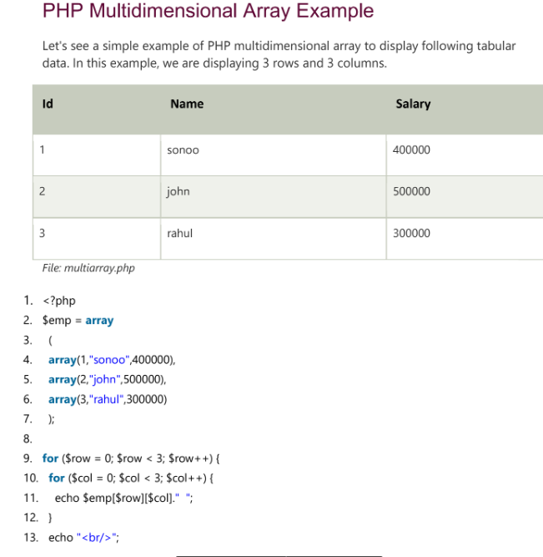

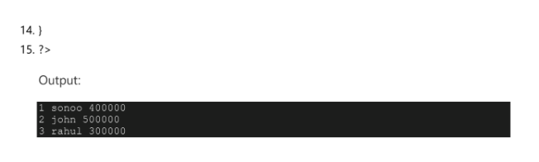

1. **Summarize the various operators supported by PHP?**

**Ans:**

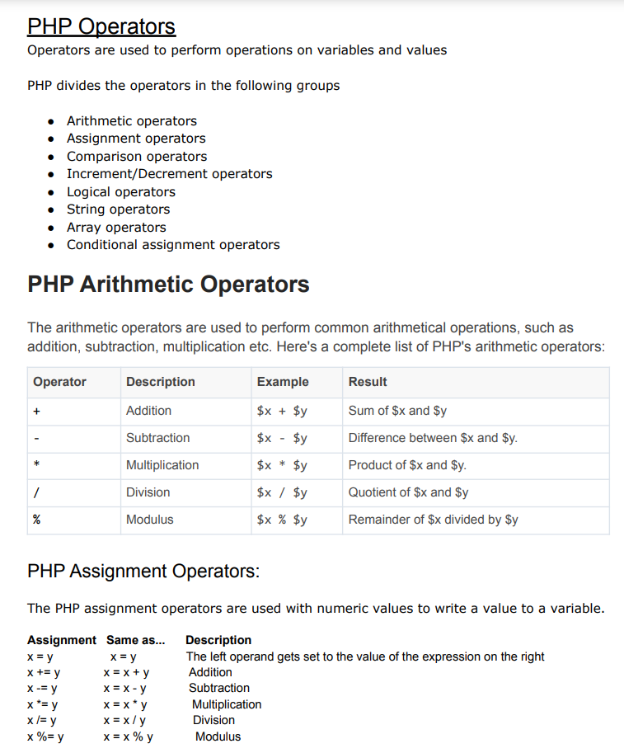

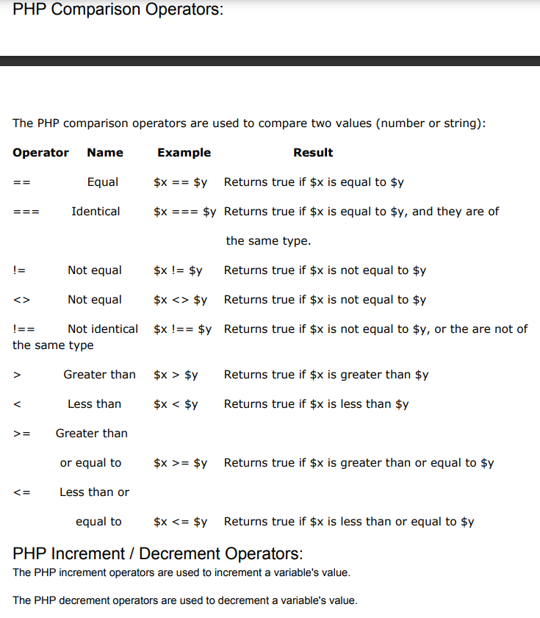

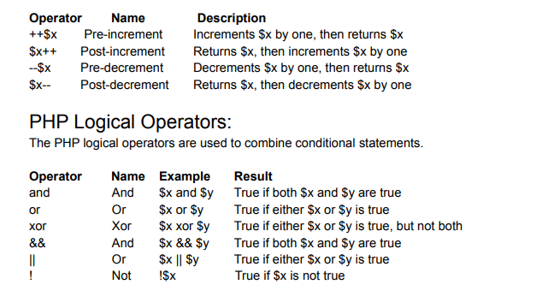

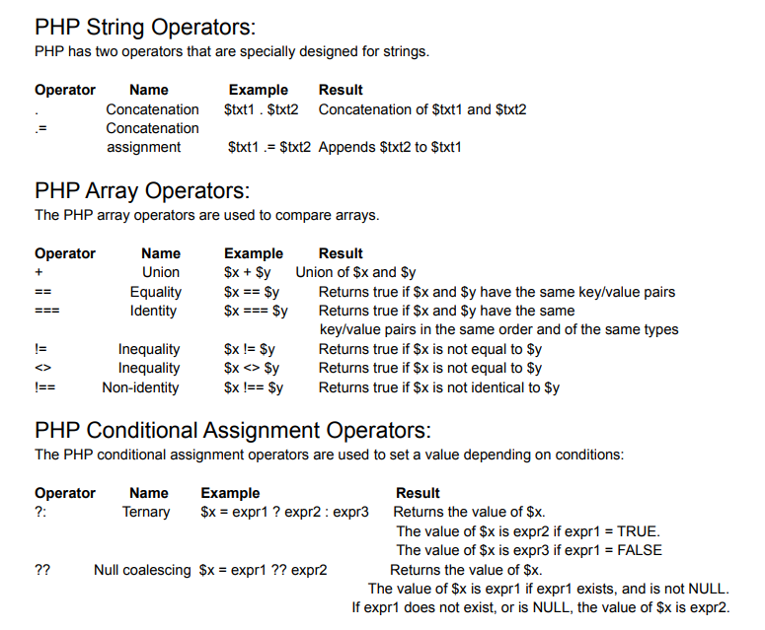

1. **Illustrate the control structures in PHP with examples**

**Ans:**

A control structure allows you to control the flow of code execution in your application. Generally, a program is executed sequentially, line by line, and a control structure allows you to alter that flow, usually depending on certain conditions.

Control structures are core features of the PHP language that allow your script to respond differently to different inputs or situations. This could allow your script to give different responses based on user input, file contents, or some other data.

The following flowchart explains how a control structure works in PHP.

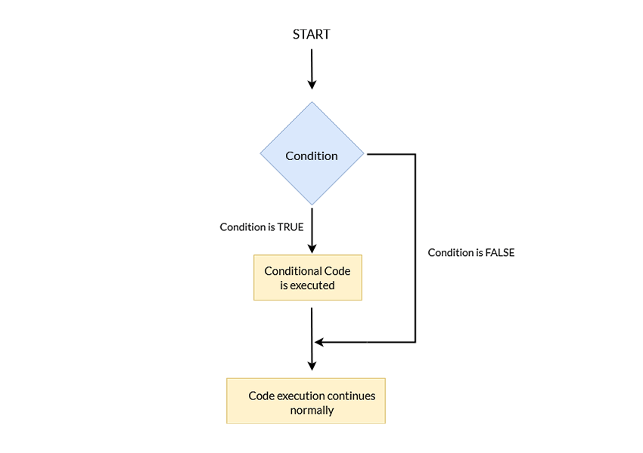

PHP supports a number of different control structures:

* if
* else
* elseif
* switch
* while
* do-while
* for
* foreach

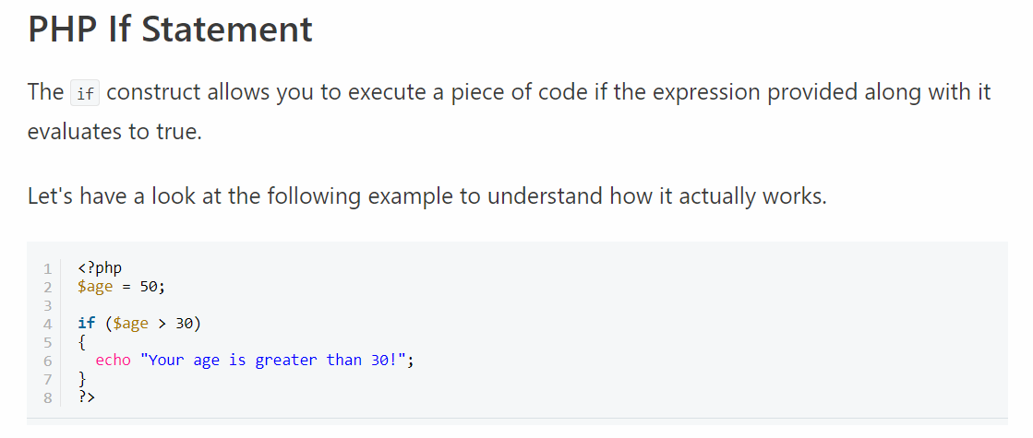

PHP ELSE Statement

 the if construct, which allows you to execute a piece of code if the expression evaluates to true. On the other hand, if the expression evaluates to false, it won't do anything.

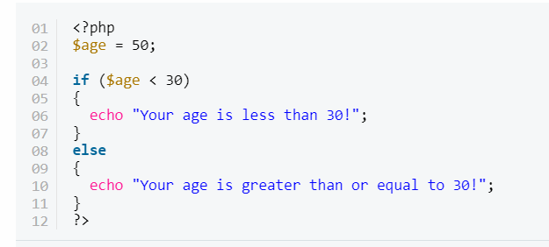

PHP Else If Statements

We can consider the elseif statement as an extension to the if-else construct. If you've got more than two choices to choose from, you can use the elseif statement.

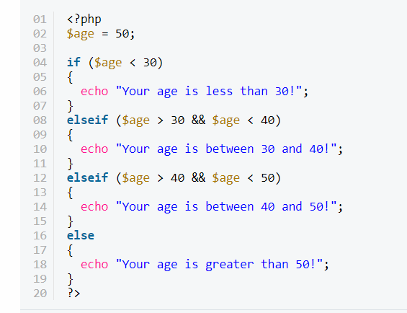

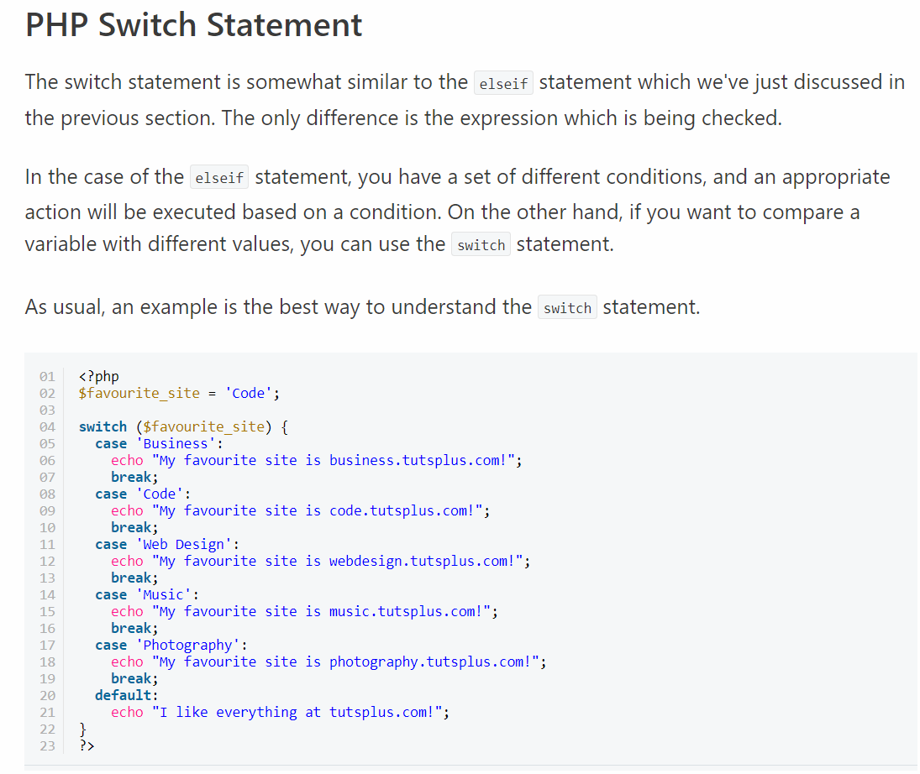

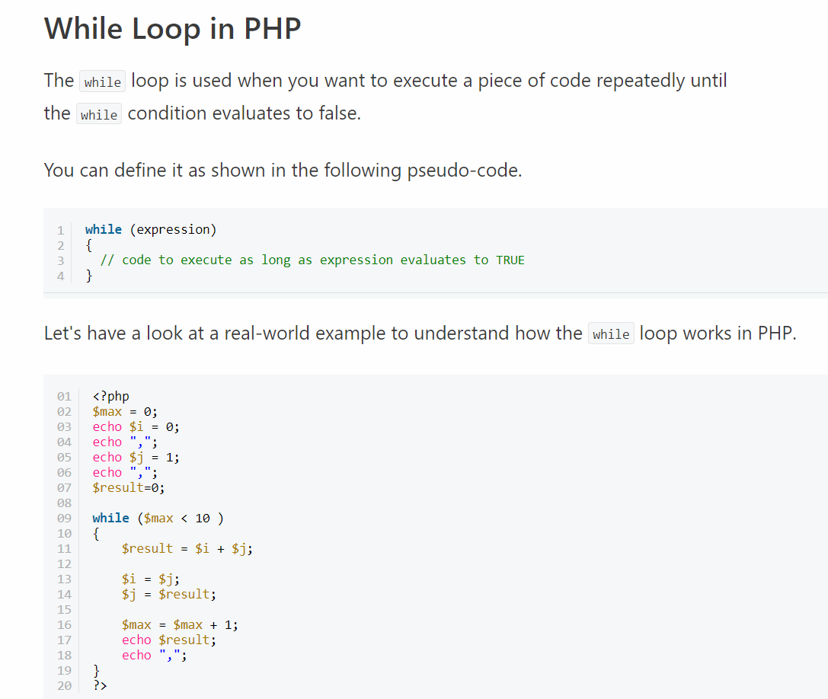

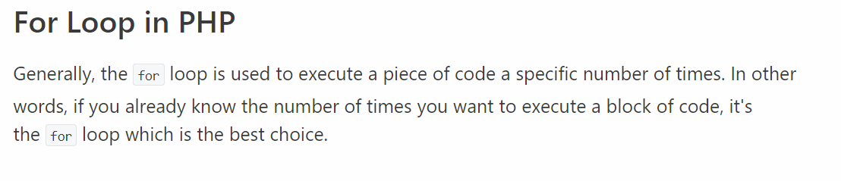

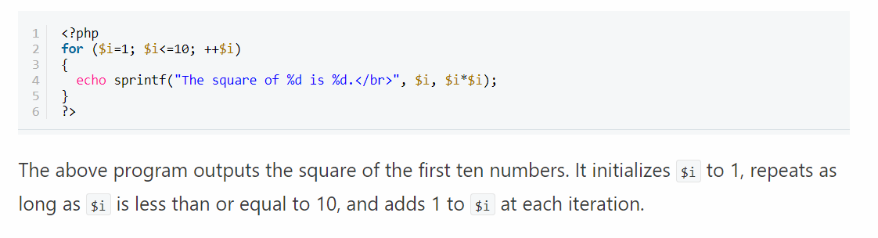

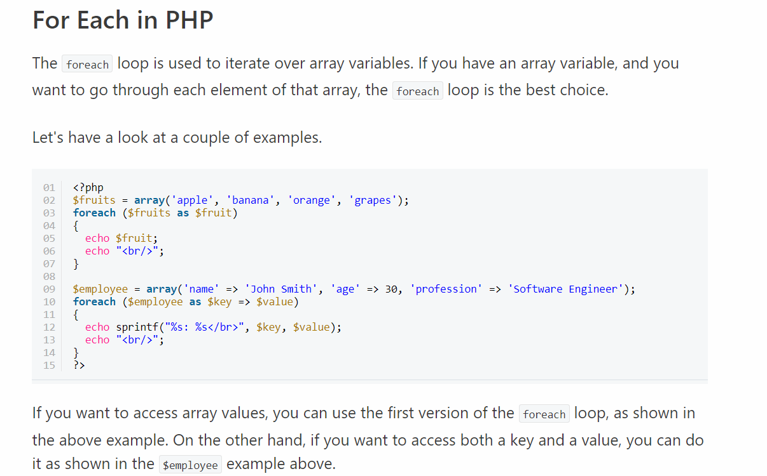

1. **Categorize various file operations on text files in PHP.**

**Ans:**

* **“w” –** Opens a file for write only. If file not exist then new file is created and if file already exists then contents of file is erased.
* **“r” –** File is opened for read only.
* **“a” –** File is opened for write only. File pointer points to end of file. Existing data in file is preserved.
* **“w+” –** Opens file for read and write. If file not exist then new file is created and if file already exists then contents of file is erased.
* **“r+” –** File is opened for read/write.
* **“a+” –** File is opened for write/read. File pointer points to end of file. Existing data in file is preserved. If file is not there then new file is created.
* **“x” –** New file is created for write only.

File handling is needed for any application. For some tasks to be done file needs to be processed. File handling in PHP is similar as file handling is done by using any programming language like C. PHP has many functions to work with normal files. Those functions are:

1) **fopen() –** PHP fopen() function is used to open a file. First parameter of fopen() contains name of the file which is to be opened and second parameter tells about mode in which file needs to be opened, e.g.,

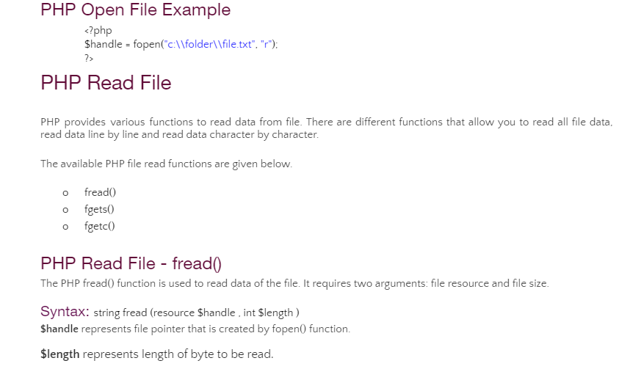

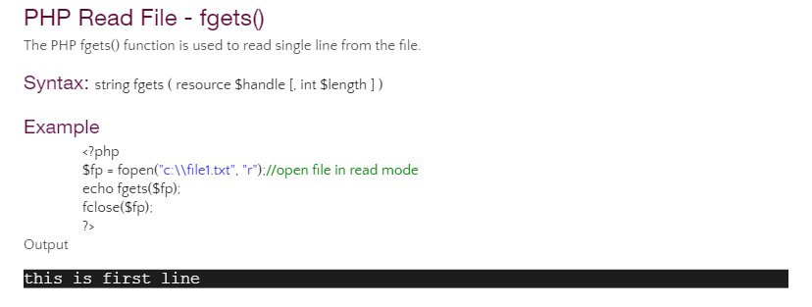

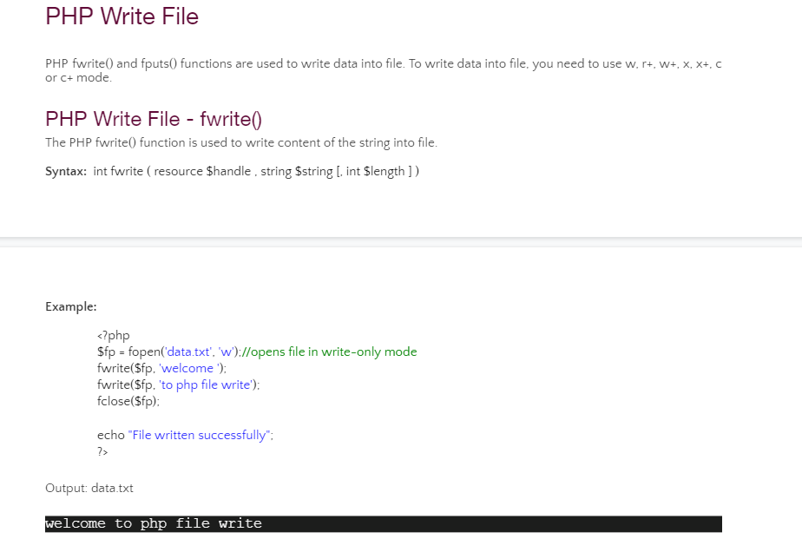

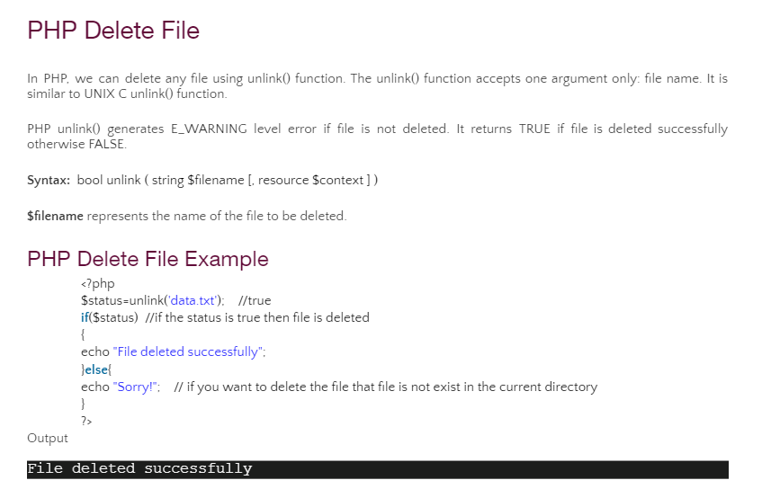

1. **List and explain the database connectivity steps in PHP with reference to MySQL**.

**Ans:**

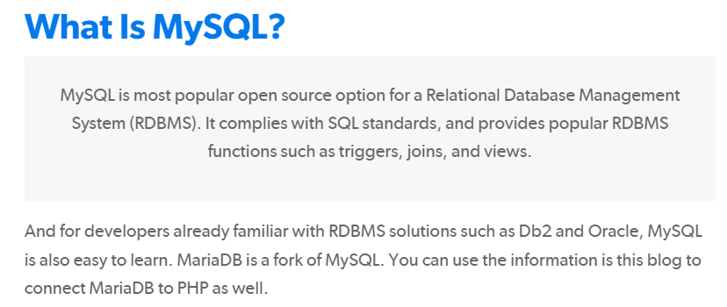

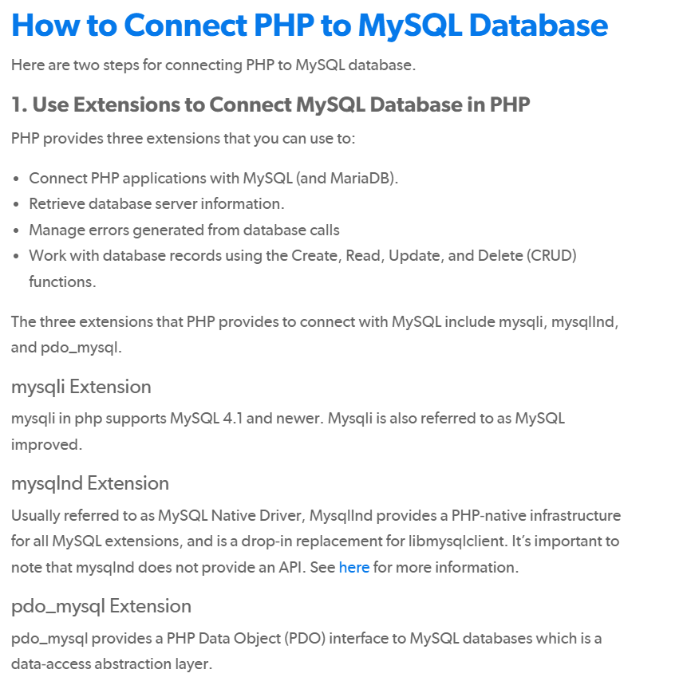

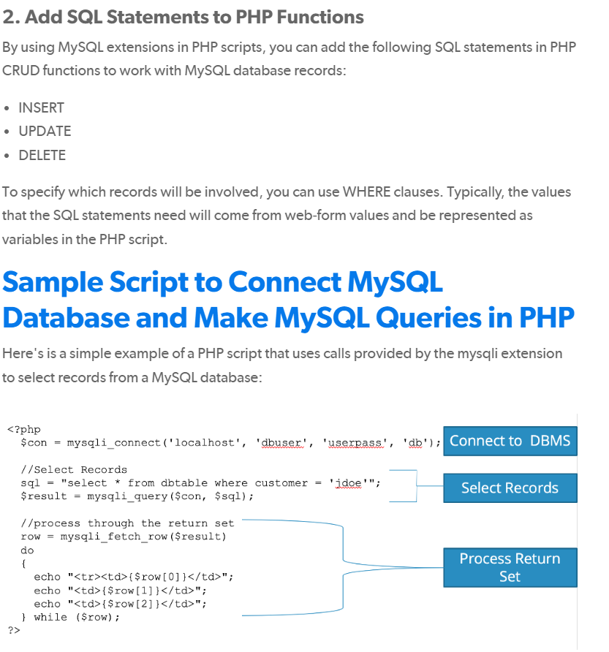

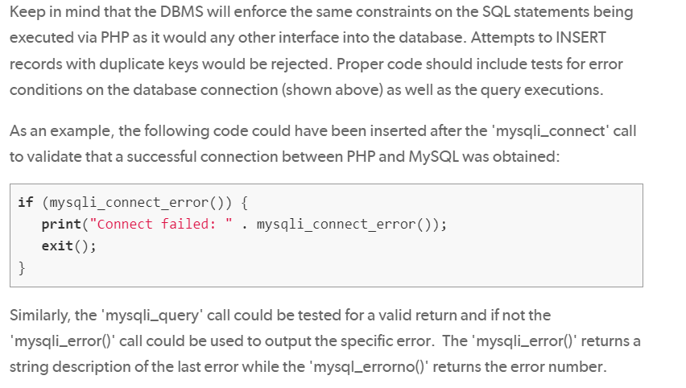

1. **Illustrate with an example, how to execute a SELECT query in PHP?**

**Ans:**

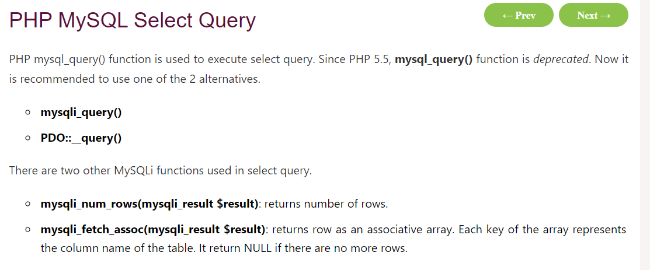

## PHP MySQLi Select Query Example

**Example**

1. <?php
2. $host = 'localhost:3306';
3. $user = '';
4. $pass = '';
5. $dbname = 'test';
6. $conn = mysqli_connect($host, $user, $pass,$dbname);
7. **if**(!$conn){
8. **die**('Could not connect: '.mysqli_connect_error());
9. }
10. echo 'Connected successfully<br/>';
12. $sql = 'SELECT * FROM emp4';
13. $retval=mysqli_query($conn, $sql);
15. **if**(mysqli_num_rows($retval) > 0){
16. **while**($row = mysqli_fetch_assoc($retval)){
17. echo "EMP ID :{$row['id']}  <br> ".
18. "EMP NAME : {$row['name']} <br> ".
19. "EMP SALARY : {$row['salary']} <br> ".
20. "--------------------------------<br>";
21. } //end of while
22. }**else**{
23. echo "0 results";
24. }
25. mysqli_close($conn);
26. ?>

Output:

Connected successfully

EMP ID :1

EMP NAME : ratan

EMP SALARY : 9000

--------------------------------

EMP ID :2

EMP NAME : karan

EMP SALARY : 40000

--------------------------------

EMP ID :3

EMP NAME : jai

EMP SALARY : 90000

--------------------------------

1. **Write a php program to create a form with actions, which consists of input fields as text, radio button, drop down menu and checked box .**

**Ans:**

**MODULE 2**

1. **a) Write an html program to embed an image into web document**

**Ans:**

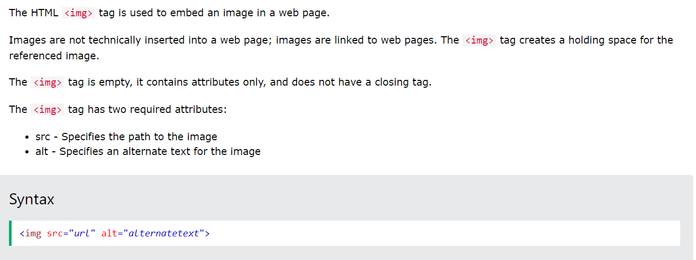

**Code:**

<!DOCTYPE html>

<html>

<head>

<style>

/* This style sets the width of all images to 100%: */

img {

width: 100%;

}

</style>

</head>

<body>

<h2>Width/Height Attributes or Style?</h2>

<p>The image uses the style attribute to set the width to 128 pixels, this will not be overridden by the style in the head section:</p>

<img src="html5.gif" alt="HTML5 Icon" style="width:128px;height:128px;">

</body>

</html>

**Output:**

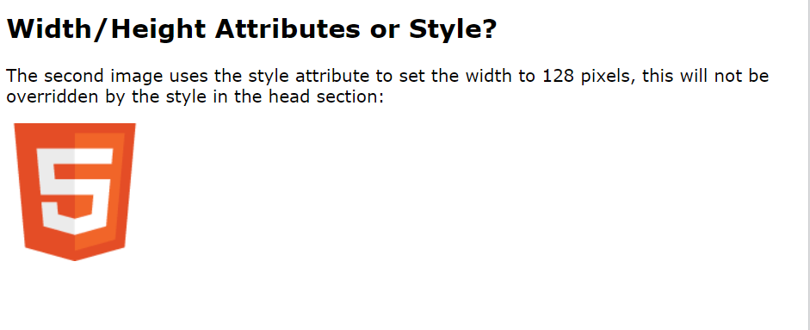

**b) Write an html program to create hyperlinks to other documents**

**Ans:**

Hyperlinks allow visitors to navigate between Web sites by clicking on words, phrases, and images. Thus you can create hyperlinks using text or images available on a webpage.

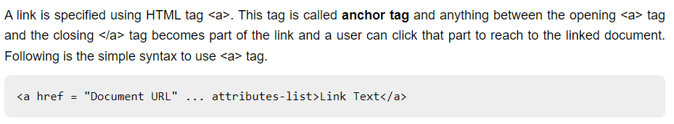

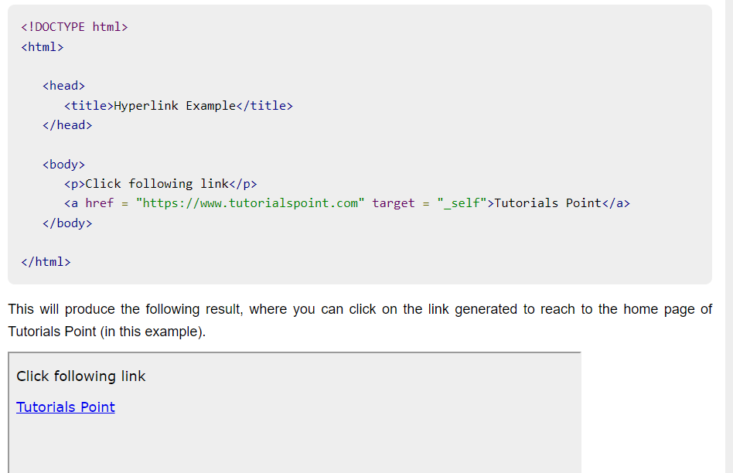

1. **Write an html program to demonstrate the working of ordered and unordered lists in html.**

**Ans:**

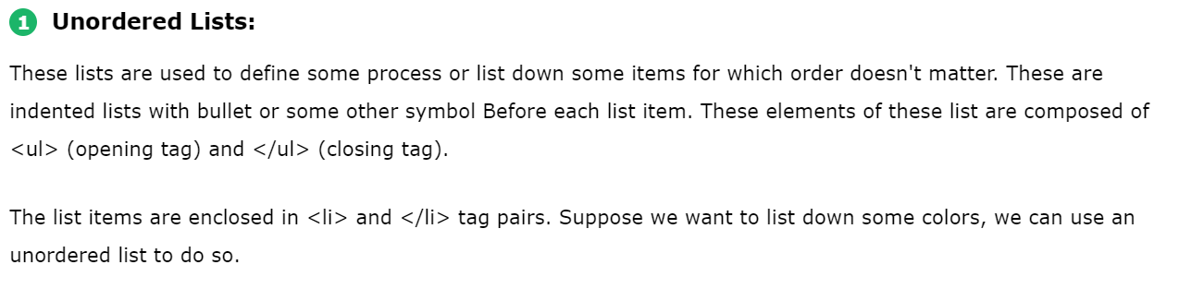

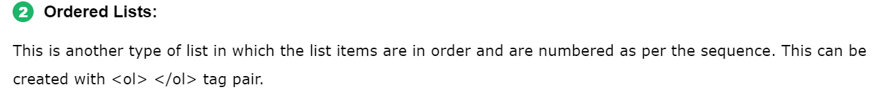

**Code:**

<!DOCTYPE html>

<html lang="en">

<head>

<meta charset="UTF-8">

<title>Types of Lists in HTML</title>

<style>

.square {

list-style: square;

font-size : 16px

}

.circle {

list-style: circle;

font-size: 16px

}

</style>

</head>

<body>

<h1 style="color:blue;text-align:center;font:24px">Example for Unordered, Ordered lists </h1>

<h2 style="color:green;text-align:left;font:20px">Unordered List</h2>

<ul>

<li>Red</li>

<li>Black</li>

<li>Blue</li>

</ul>

<h2 style="color:green;text-align:left;font:20px">Ordered List</h2>

<ol>

<li>Getting up at 6</li>

<li>Outdoor running for 45 mins</li>

<li>Getting ready by 8</li>

<li>Breakfast by 8:30</li>

<li>Reach office by 9:30</li>

</ol>

</body>

</html>

**Output:**

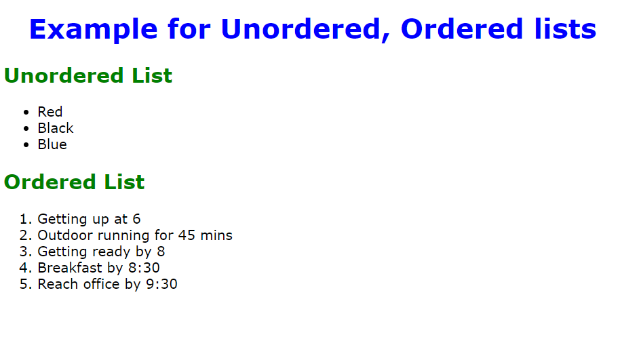

1. **Write a program to create an internal cascading style sheet using a) Id Selectors b) Class Selector**

**Ans:**

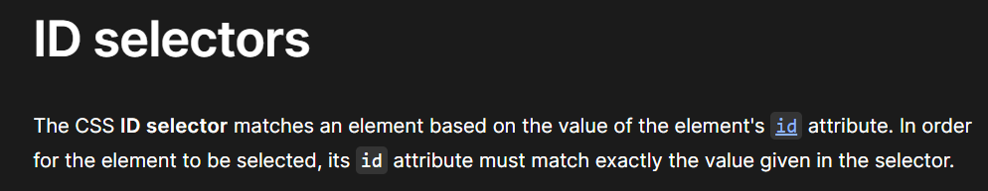

**Code:**

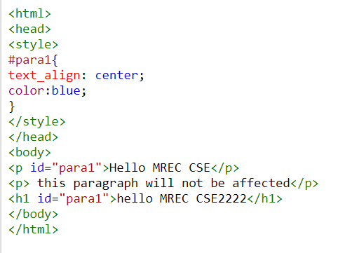

**Output:**

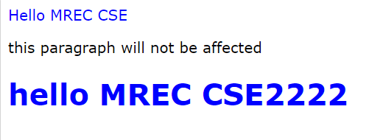

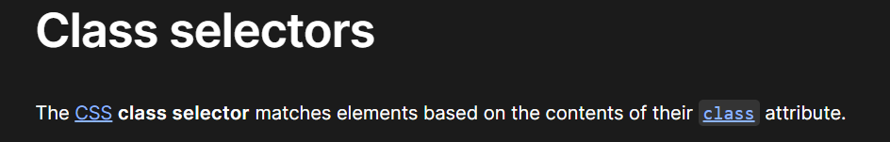

**Code:**

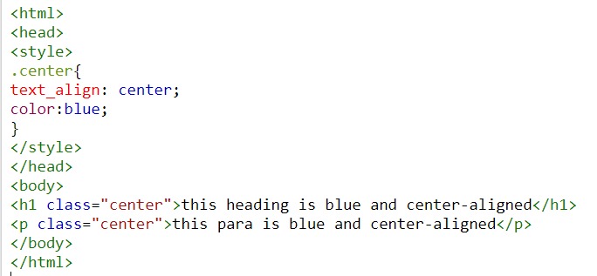

**Output:**



1. **Write short notes on a) Internal CSS b) External CSS**

**Ans:**

# **a)Internal CSS**

* The internal style sheet is used to add a unique style for a single document. It is defined in <head> section of the HTML page inside the <style> tag.
* But in the Internal CSS, we can not control styles for multiple documents at once
* Internal style Sheet is applicable to the Page in which it is included.
* Internal Style Sheet is used to style individual page.

**Code:**

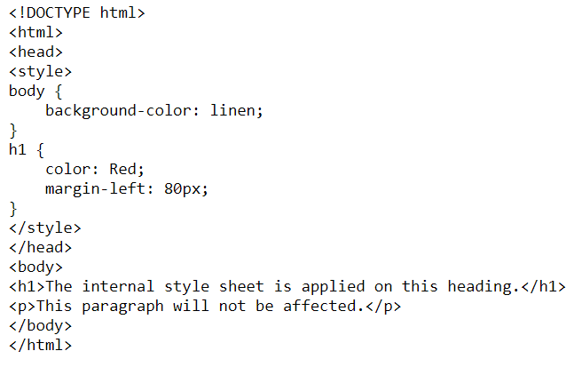

**Output:**

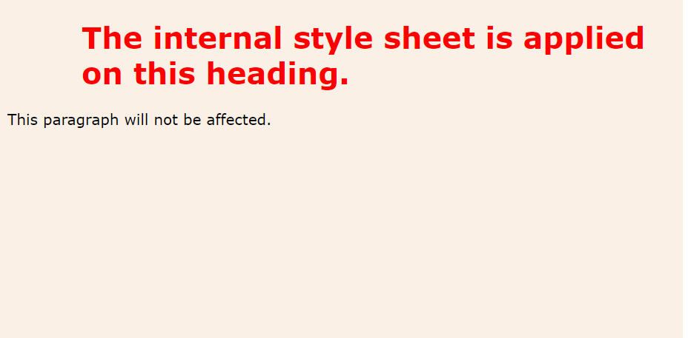

# **b)External CSS**

The external style sheet is generally used when you want to make changes on multiple pages. It is ideal for this condition because it facilitates you to change the look of the entire web site by changing just one file.

It uses the <link> tag on every pages and the <link> tag should be put inside the head section.

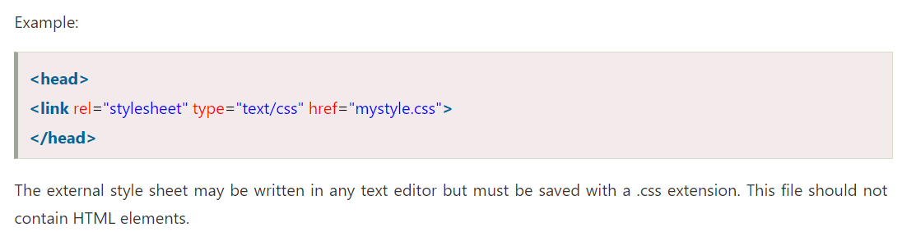

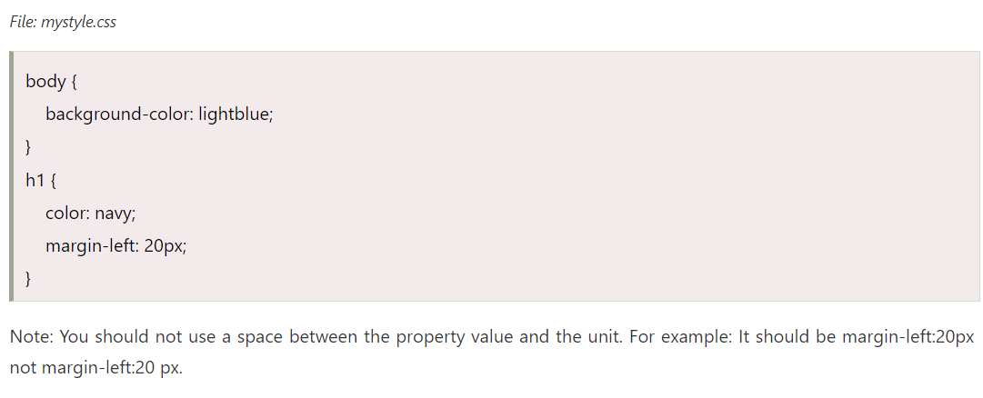

1. **Extend the features of XML namespaces and explain how are they declared?**

**Ans:**

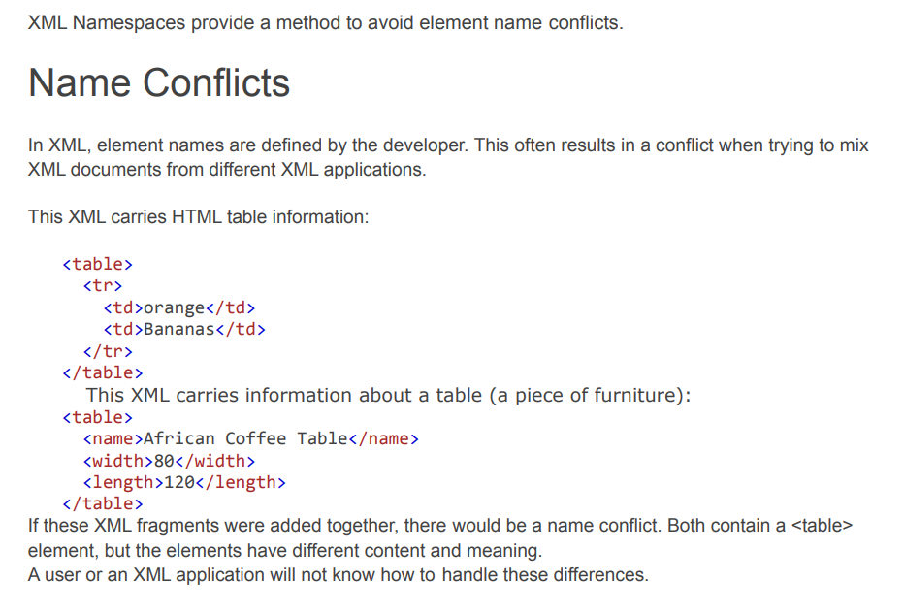

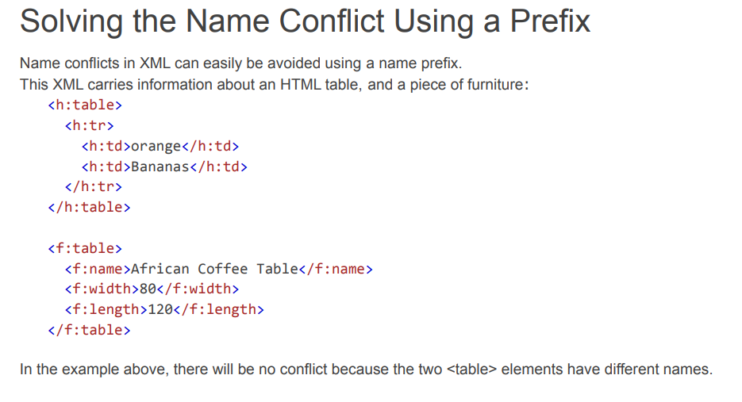

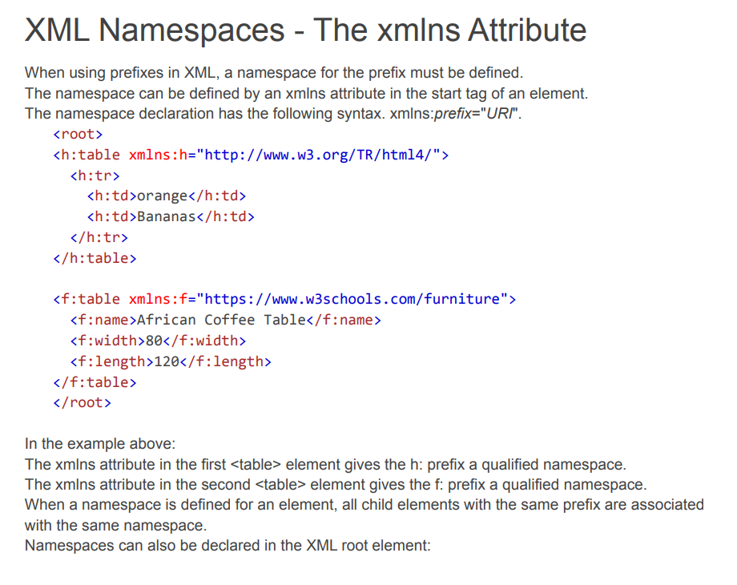

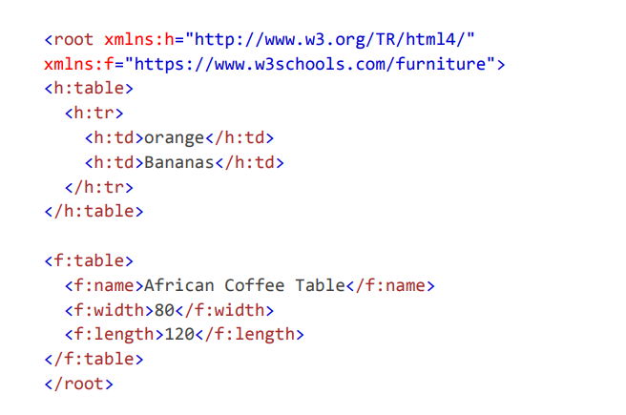

1. **Identify the need for ‘XML Parser’. Explain with an example**

**Ans:**

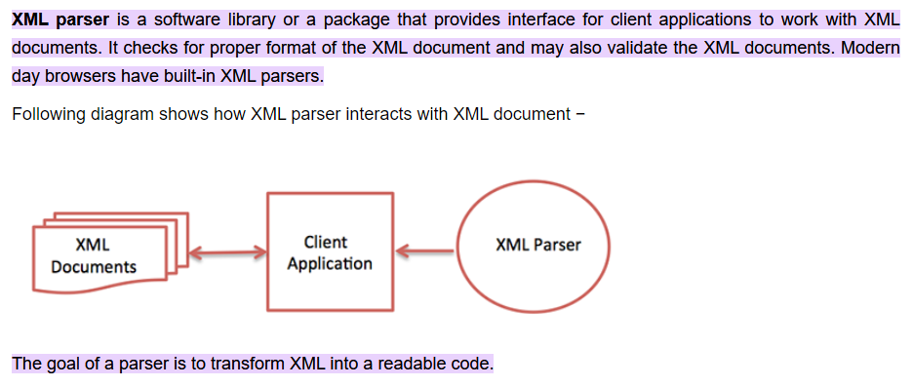

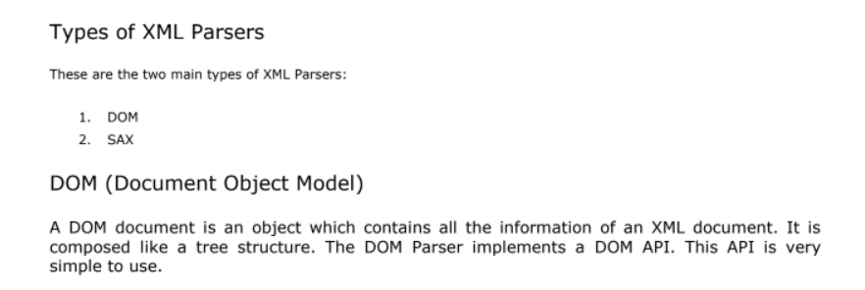

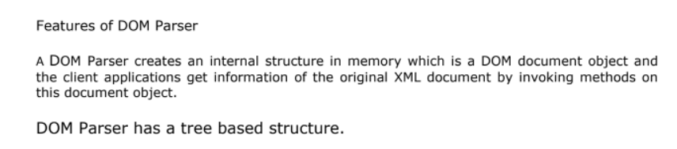

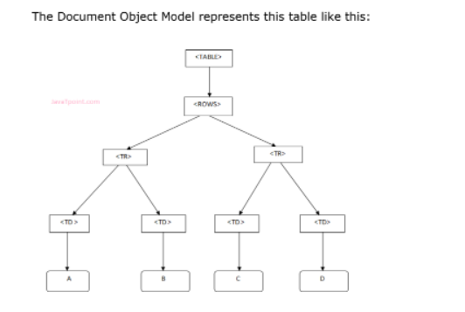

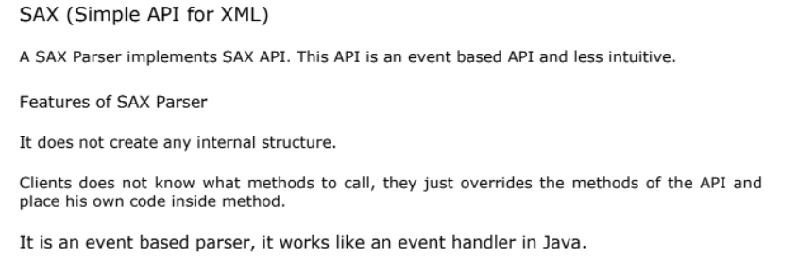

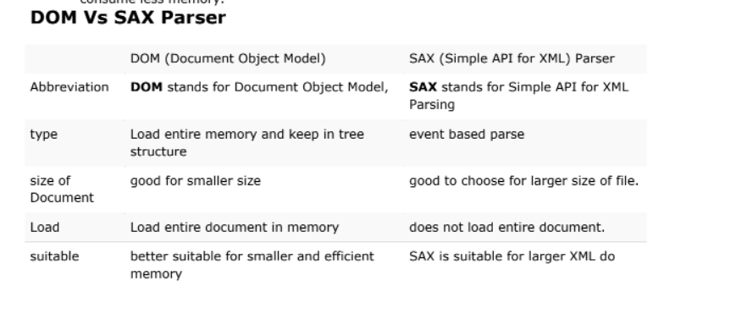

1. **Summarize the various types of XML parsers.**

**Ans:**

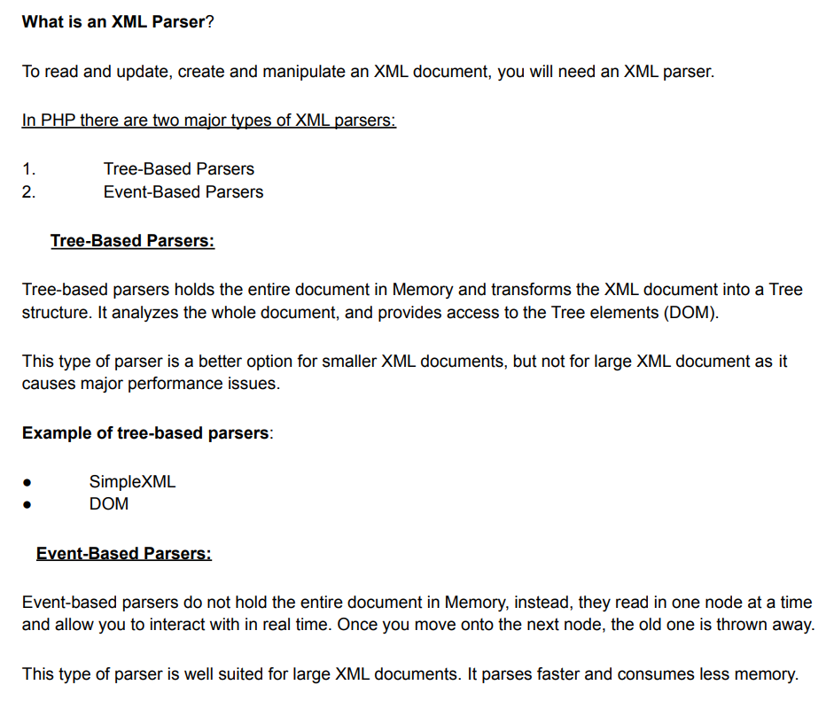

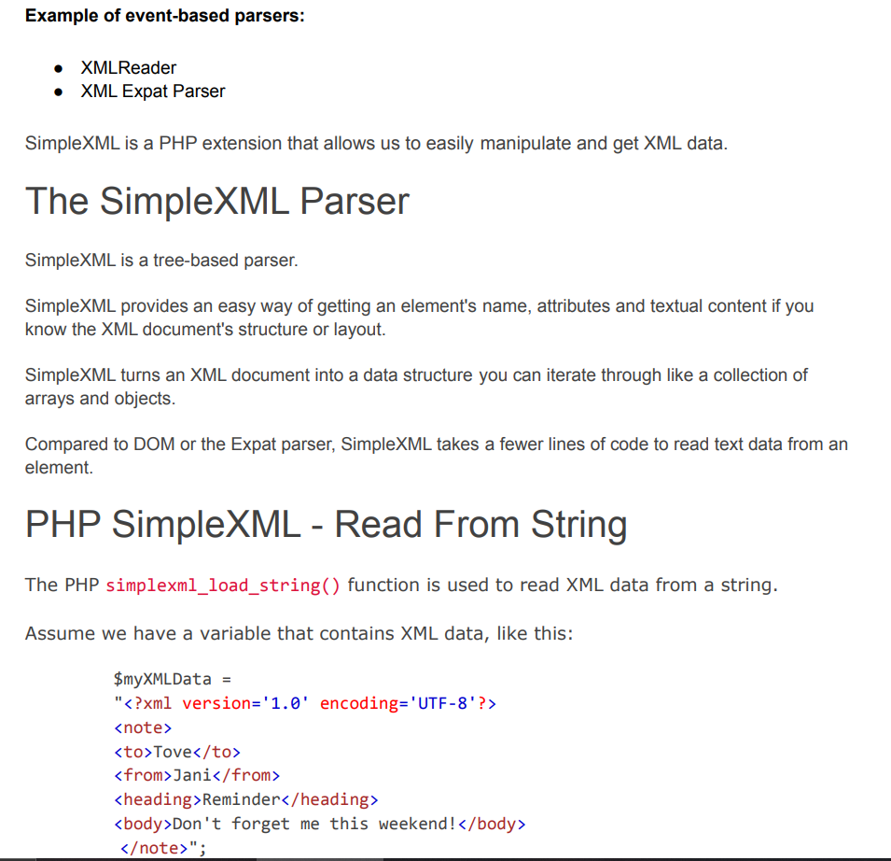

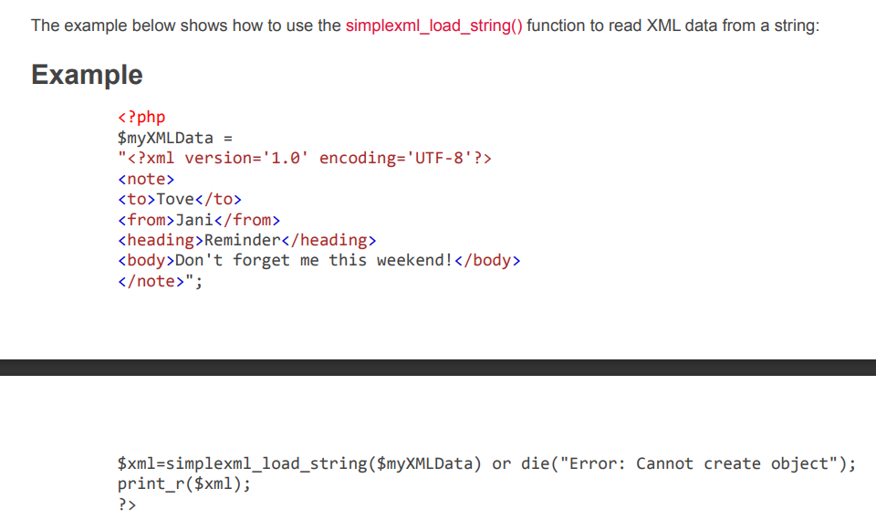

1. **Outline the features of XML Schema. State its purpose and list its advantages over DTD**

**Ans:**

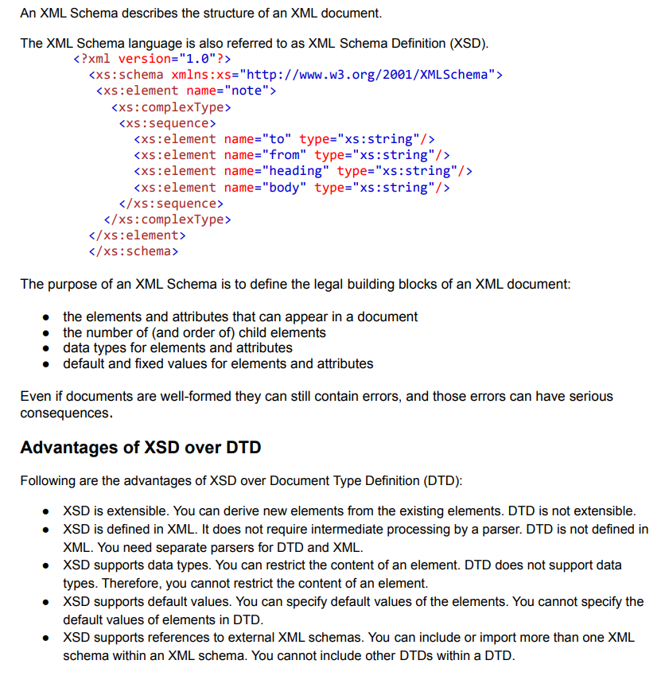

**MODULE 3**

1. **Explain the potential advantages do servlets have over CGI programs.**

**Ans:**

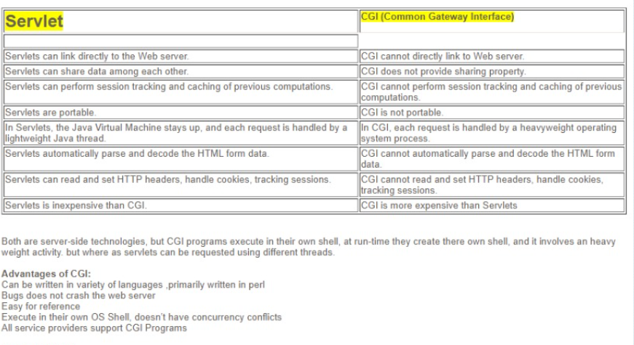

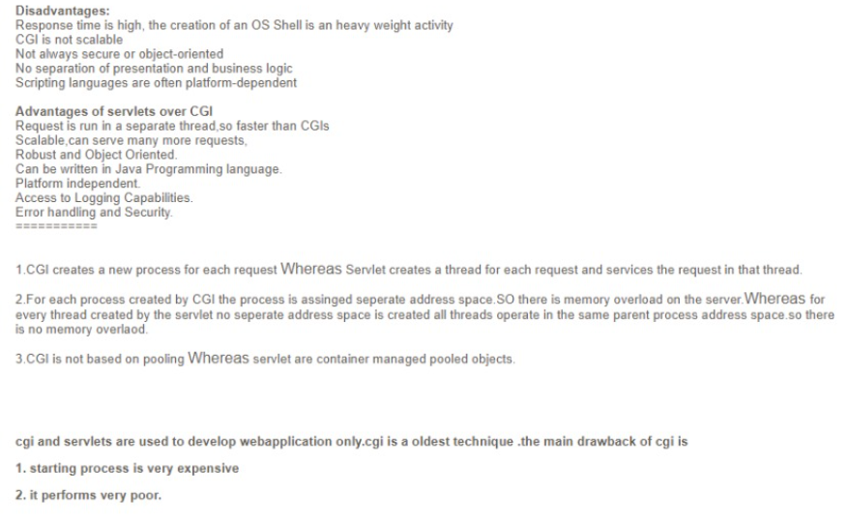

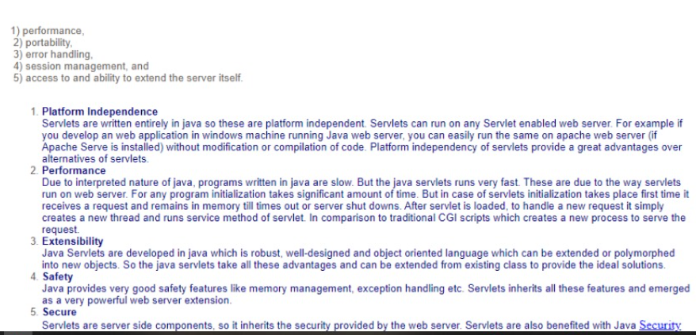

1. **Summarize the life cycle of a java servlet with a neat diagram.**

**Ans:**

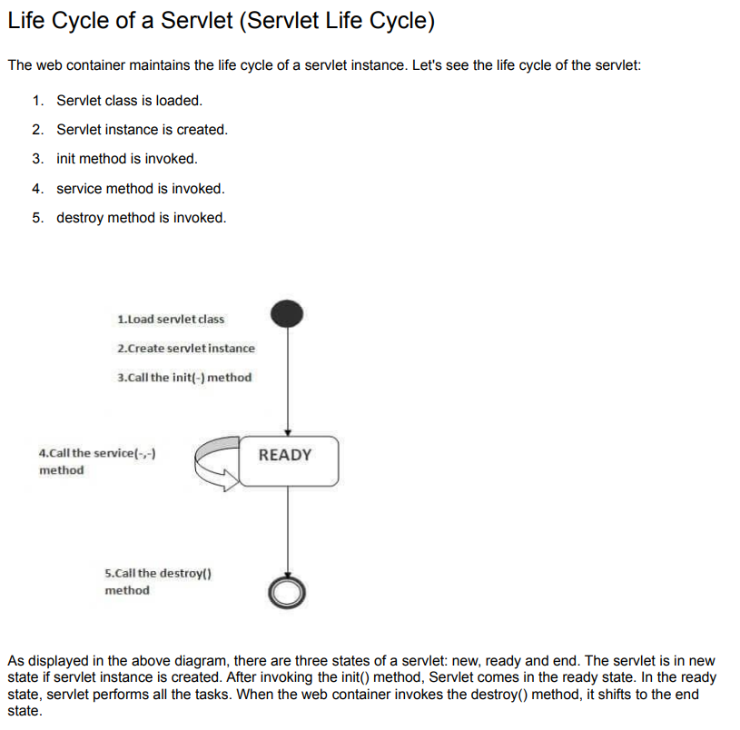

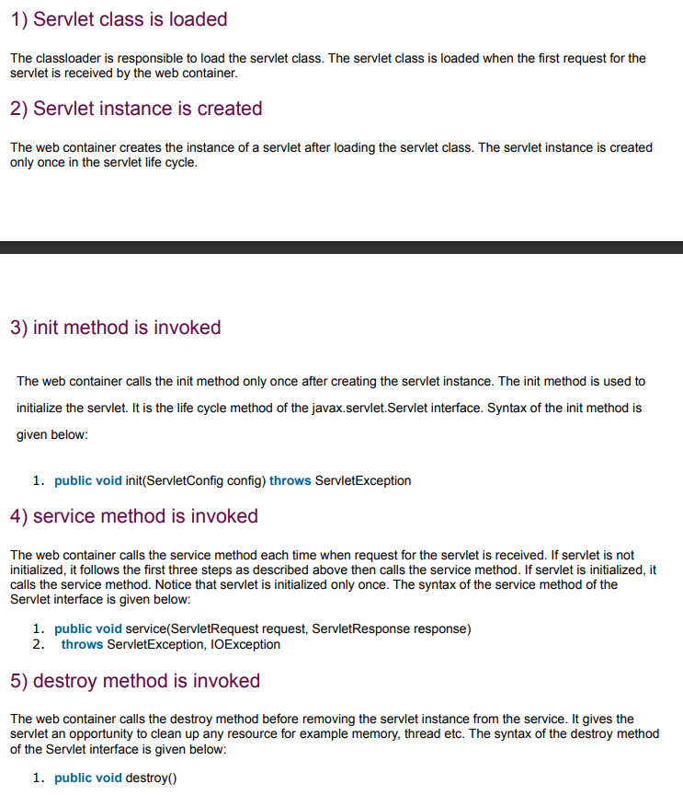

1. **Write short notes on ServletConfig and ServletContext**.

**Ans:**

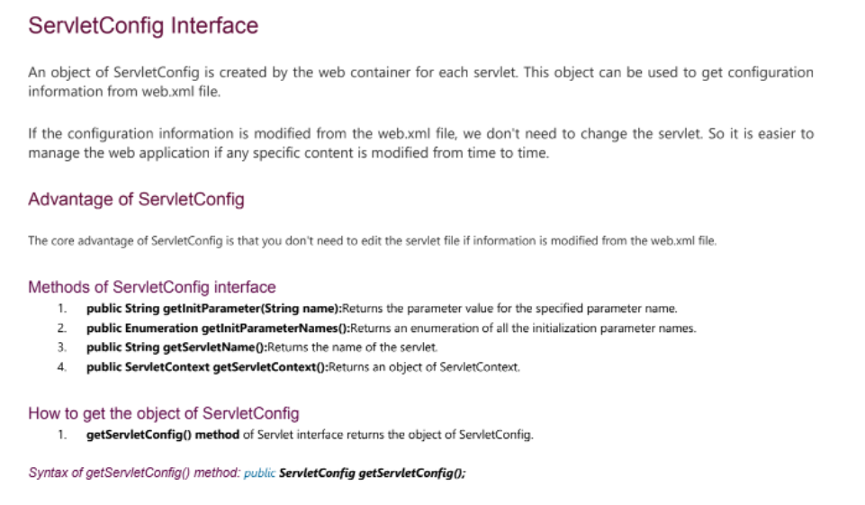

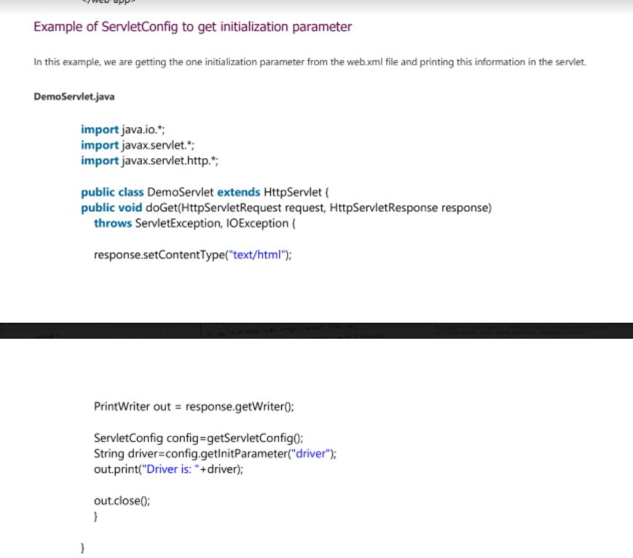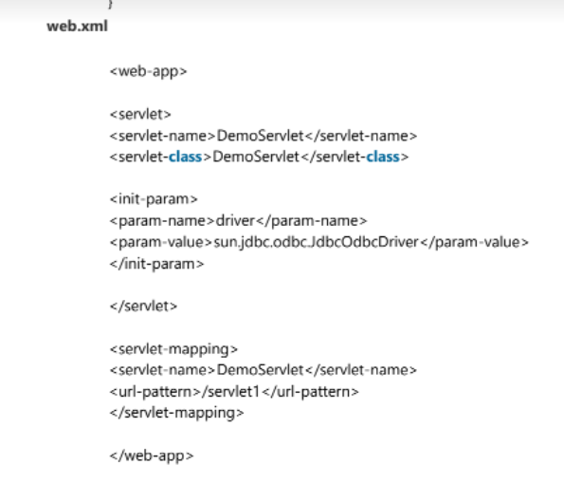

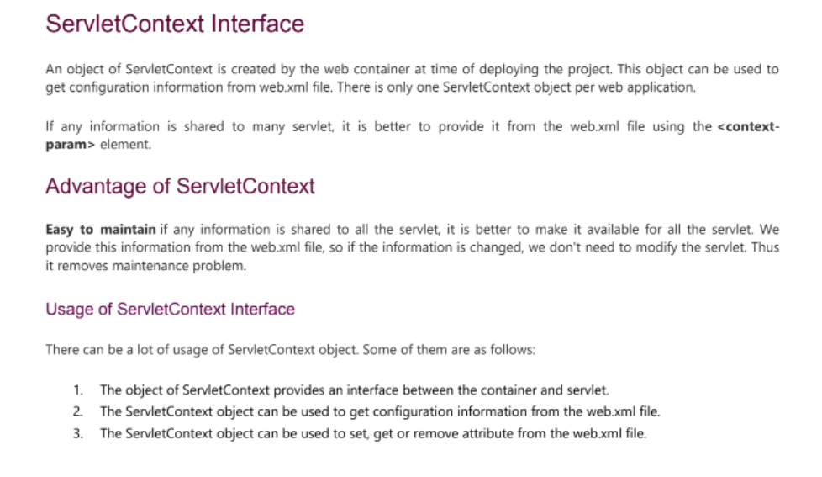

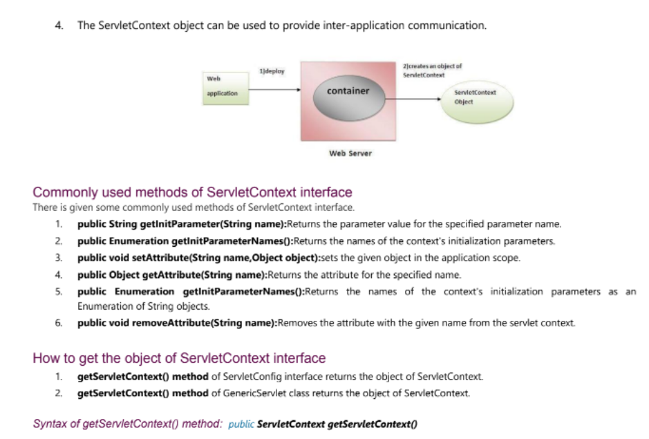

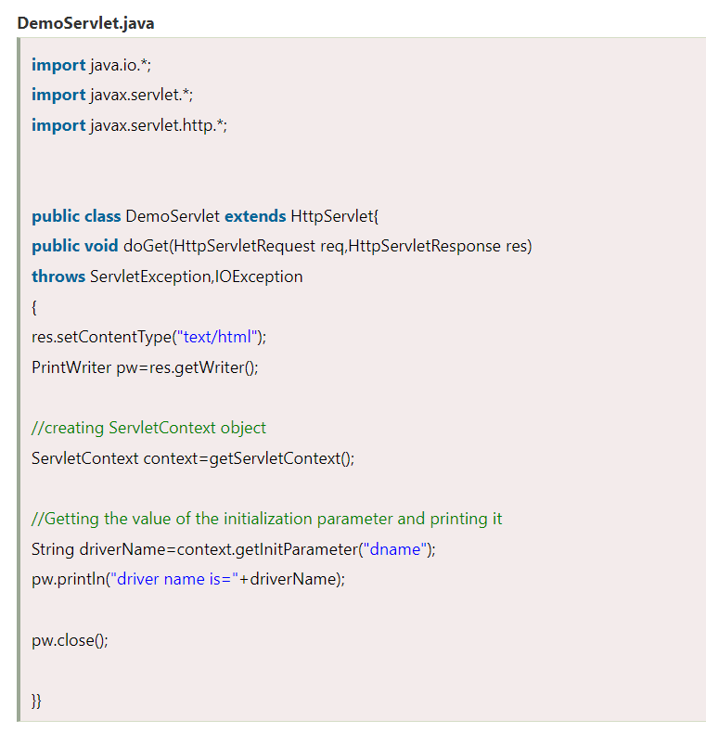

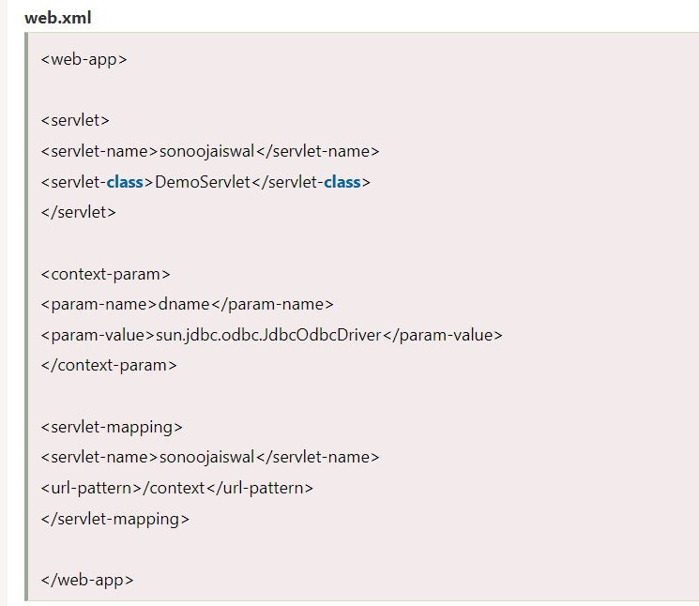

(the codes of ServletConfig and ServeltContext have only slight changes**)**

1. **Elaborate the differences between Generic Servlet and HttpServlet.**

**Ans:**



